Part #2- Read passages & find evidence by following these steps:
1. Speed read each passage by reading titles, first and last paragraphs, and headings.
2. Identify the main idea of each passage.
3. Close read each passage by reading every word and highlighting useful information.
4. Number the 3 most important things you highlighted in each text.
PASSAGE 1- Main Idea:
WHY ALL THE BUZZ ABOUT BLACK BEARS?
from: http://www.state.nj.us/dep/fgw/bearfacts_kids.htm
Black bears live in many of the United States. They were here long before people were. About 100 years ago, black bears were almost gone from some states because the forests in which they make their homes were being cut down for lumber, farming and towns. Today, there are more black bears and more people than ever before.
Black bears are now recognized as an important natural resource in New Jersey and as part of the state's heritage. They have been sighted throughout the state. People can see bears in forests when they are hiking and camping, and some people even see bears in their yards.
It is important to remember that black bears are large, wild animals. If you see a black bear, you should never go near it. Instead, watch it from far away. Never feed or try to pet a black bear. Black bears learn very quickly. If they learn to associate people with food, they may lose their fear of people, which can be dangerous. Treat black bears with respect.

IF YOU SEE A BEAR

If a bear comes into your yard or you see one while camping, do not be afraid, but remember bears are not tame animals, they are wild creatures.

Here are some tips that you should follow if you see a bear:

- Do not get scared and do not run.
- Talk to the bear to let it know you are there.
- Never feed the bear!
- Do not go near the black bear.
- Do not look directly into the bear's eyes.
- Make sure the bear can get out of your yard or campground easily if it wants to. Don't stand in front of the escape route!
- Make lots of noise. It could scare the bear away.
- If you are playing with friends, get in a big group. Talk and wave your arms. You will look really big and the bear might leave.
- Always tell your parents if you see a bear!

Bears can make a lot of noise, so they may huff, snap their jaws and slap the ground if they think you are too close. Back away slowly.

A bear that stands on its back legs is not about to attack you. It just wants to see and smell you better. Let a bear know you are there by waving your arms and talking to it.

Bears may pretend to attack by running at you. DO NOT RUN! Back away slowly and get to a safe area.
Black bears rarely hurt people. If a black bear attacks, fight back!

PASSAGE 2- Main Idea:
Bears Become a Big Problem in Central Florida

By Orlando Sentinel, adapted by Newsela staff Date: 01.02.14
ORLANDO, Fla. — People used to be excited to see the black bears by their homes. Sure, more people were complaining. But the bears kept appearing. And that made for fun Facebook posts and interesting talk. No one had been badly hurt yet because of a bear. Experts told people that the bears would leave them alone. They just had to follow some simple rules.

But all of that changed on Dec. 2. Susan Chalfant, 54, was hurt badly while walking her two small dogs. It was the most serious bear attack in Florida's history.

People Want More Protection
Since the attack, people who live where bears roam say they are scared. They don't think the state is doing enough to protect them.

David Simmons is in Florida's government. He said the bears are showing up where people have been living for a long time. He said it's not that people are moving into places where bears live. Bears are now moving to where people live. And that's causing problems.

Nick Wiley is in charge of the Florida's wildlife agency. He said his workers have done a lot to protect people. He said his workers will kill a bear if it is not scared of people and trying to stay away from them. They don't like doing it, but "people come first,” he said. The agency plans to get more workers to trap bears. Then they can be moved to other places. Or the workers will catch and kill the bears. They are also asking people to make changes, like keeping their garbage cans locked and not feeding their pets outside. But people say the changes aren't helping.

Too Close For Comfort
Inga Bateman had liked living among the black bears — even if it meant making some changes. She didn’t leave pet or bird food out. She got rid of her blueberry bushes. She planted thorny rose bushes to keep the bears away. Bateman, 56, loved telling friends about one Christmas Eve. A bear ate her children’s chocolate Santas when she left her car door open.

But then a bear charged Bateman twice while walking her dogs. Now she is feeling less safe. The last time, she shut her door as the bear tried to get inside her home. She hit it on the nose with the door handle. After she closed the door, the bear started pounding on the windows. It finally walked away, leaving paw prints on the windows. Bateman got so scared that she had to go to the hospital. She had called 911. But, no one came.
Bateman said, “I want them to take it more seriously.”

A Rising Problem
Wiley said the state’s bear population was once “really in trouble.” But, it has gotten back to “more natural levels. ” That helps explain the sudden rise in people having problems with the bears.

Florida’s struggle with bears is not unusual, said wildlife scientist John Beecham. Wildlife scientists from New Jersey to Colorado have reported more problems with black bears. Large animals have wandered into parks where children play. And they've been found on walking paths to schools.

New Jersey and Georgia allow bear hunting as a way to lower the number of bears. However, bear hunting hasn't helped much to control the number of bears in Georgia.

Bear hunting is not permitted in Florida. Wiley from the Florida wildlife agency says smart ways to deal with bear problems need to be found. “Asking about bear hunts I don’t think is the right question here.”

PASSAGE 3- Main Idea:

Black Bear

Ursus americanus
Black bears are North America's most familiar and common bears. They typically live in forests and are excellent tree climbers, but are also found in mountains and swamps. Despite their name, black bears can be blue-gray or blue-black, brown, cinnamon, or even (very rarely) white.
Black bears are very opportunistic eaters. Most of their diet consists of grasses, roots, berries, and insects. They will also eat fish and mammals—including carrion—and easily develop a taste for human foods and garbage. Bears who become habituated to human food at campsites, cabins, or rural homes can become dangerous and are often killed—thus the frequent reminder: Please don't feed the bears! Mother black bears are notoriously protective of their cubs, who stay with their mothers for about two years.

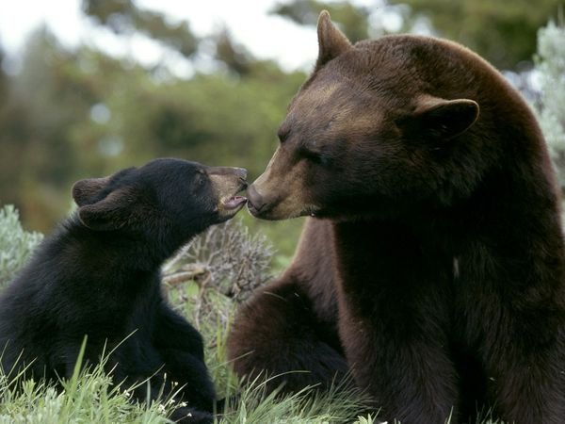
Solitary animals, black bears roam large territories, though they do not protect them from other bears. Males might wander a 15- to 80-square-mile (39- to 207-square-kilometer) home range.
When winter arrives, black bears spend the season dormant in their dens, feeding on body fat they have built up by eating ravenously all summer and fall. They make their dens in caves, burrows, brush piles, or other sheltered spots—sometimes even in tree holes high above the ground. Black bears den for various lengths of time governed by the diverse climates in which they live, from Canada to northern Mexico.
Female black bears give birth to two or three blind, helpless cubs in mid-winter and nurse them in the den until spring, when all emerge in search of food. The cubs Photograph by Norbert Rosing
will stay with their very protective mother for about two years.
Part #3- Brainstorm for & outline your essay.
1. Brainstorm about you have read, use whatever style you choose.
2. Decide on a claim and fill out the outline on the right.

Part #4- Write your essay after brainstorming and outlining. Staple it to this packet when you are done. | 1. Claim:  A. Reason #1:  B. Reason #2:  C. Reason #3:  2. Reason #1:  A. Evidence #1:  B. Evidence #2:  C. Evidence #3:  D. Inference:  3. Reason #2:  A. Evidence #1:  B. Evidence #2:  C. Evidence #3:  D. Inference:  4. Reason #3:  A. Evidence #1:  B. Evidence #2:  C. Evidence #3:  D. Inference:  5. Counterclaim:  A. Rebuttal:  B. Repeat claim  C. Repeat reasons 1-3

