Characterization Notes
Characterization:
how an author reveals a character’s role & personality
Round character:
a who appears and we learn ________ about them.
Flat character:
a who appears and we learn ________ about them.
Dynamic character:
a who learns and throughout the book.
Static character:
a who ________ learn or throughout the book.
protagonist:
the major character who narrates or is the main actor in the conflicts
antagonist:
the character, force, or entity that challenges the protagonist causing a conflict

Characterization:
how an author a character’s
role &
Round character:
a who appears and we learn ________ about them.
Flat character:
a who appears and we learn ________ about them.
Dynamic character:
a who learns and throughout the book.
Static character:
a who ________ learn or throughout the book.
Protagonist:
the who or is the main actor
in the
Antagonist:
the , , that challenges the protagonist causing a
Directions: Place each of the characters we have met in the chart where you think they belong.
Round Dynamic | Round Static
Friends:  Antagonists: | Friends:  Antagonists:
Flat Dynamic | Flat Static
Friends:  Antagonists: | Friends:  Antagonists:
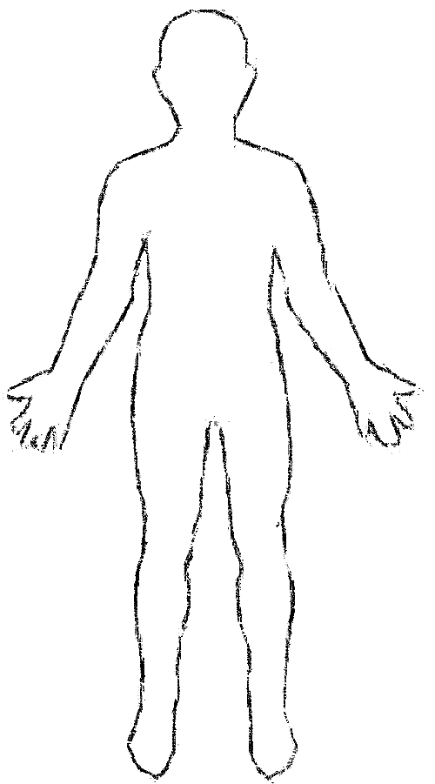
What do I say/talk about?
What are my dreams and strengths?
What are my challenges/weaknesses?
What is my family/community like?
What are my hobbies?
What things do I love?

