Team Name:
Contact Info | Members’ Names
Form A Team of 5-8 NJHS Members

To Do List:
1.
2.
3.
4.
5.
6.
7.
8.
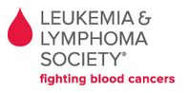
Here Is What We Are Doing
For our SOJH National Junior Honor Society service project, we are collecting coins for the Leukemia & Lymphoma society. Our donations help with research and treatment for kids fighting blood cancers.
NJHS members will get into teams with 5 or 6 members. Each team will work together to gather coins. The teams will be competing for a pasta lunch from Olive Garden. Olive Garden has agreed to provide a free catered lunch for the top 5 donating teams.
In order to win, teams must deposit their coins at a Coinstar kiosk and put the receipts in their team’s box. The NJHS advisors will keep track of how much each team donates, and the top 5 teams will be invited to the lunch.
Here Is What You Do With Your Coins
Take the coins you have gathered to the Coinstar location nearest to you. Only some of the Coinstars in our area let you send the money directly to the Leukemia & Lymphoma Society. Make sure to choose one from the list on the right. Below are the directions for how to use the machine. Once you have deposited the coins, bring the receipt to school so that your team can win! Remember, the school will not be collecting any of the money. The school is only collecting the receipts.
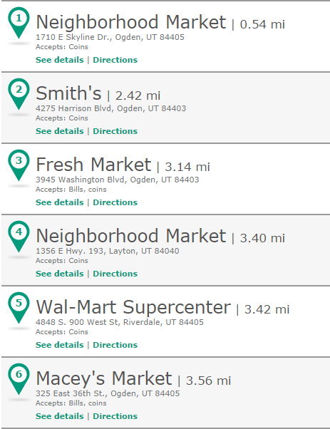
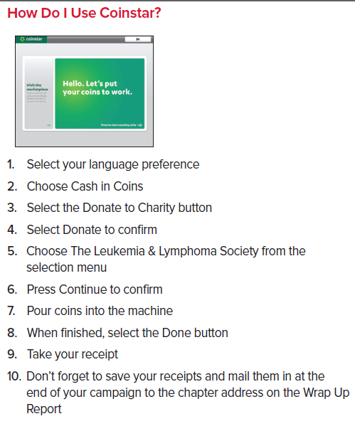
Coinstar Locations To Use

