/ Name:
Period:
ENGLISH: GRAMMAR OLYMPICS
1. Punctuation- Choose a punctuation mark to and make an Olympic illustration out of it. | 2. Nouns- list as many common or proper nouns from the Olympics as you can think of:  Total: ______ | 4. Verbs- list all of the verbs you can think of that happen during the Olympics:  Total: ______
 | 3. Adjectives- choose to noun adjective pairs that are funny.  1. ________________________________  2. ________________________________ | 5. Adverbs- choose three verbs above to describe with a powerful adverb.  1. ________________________________  2. ________________________________  2. ________________________________
Directions: Answer the questions below. Be prepared to share your answers with the class.

/ Name:
Period:
ENGLISH: GRAMMAR OLYMPICS
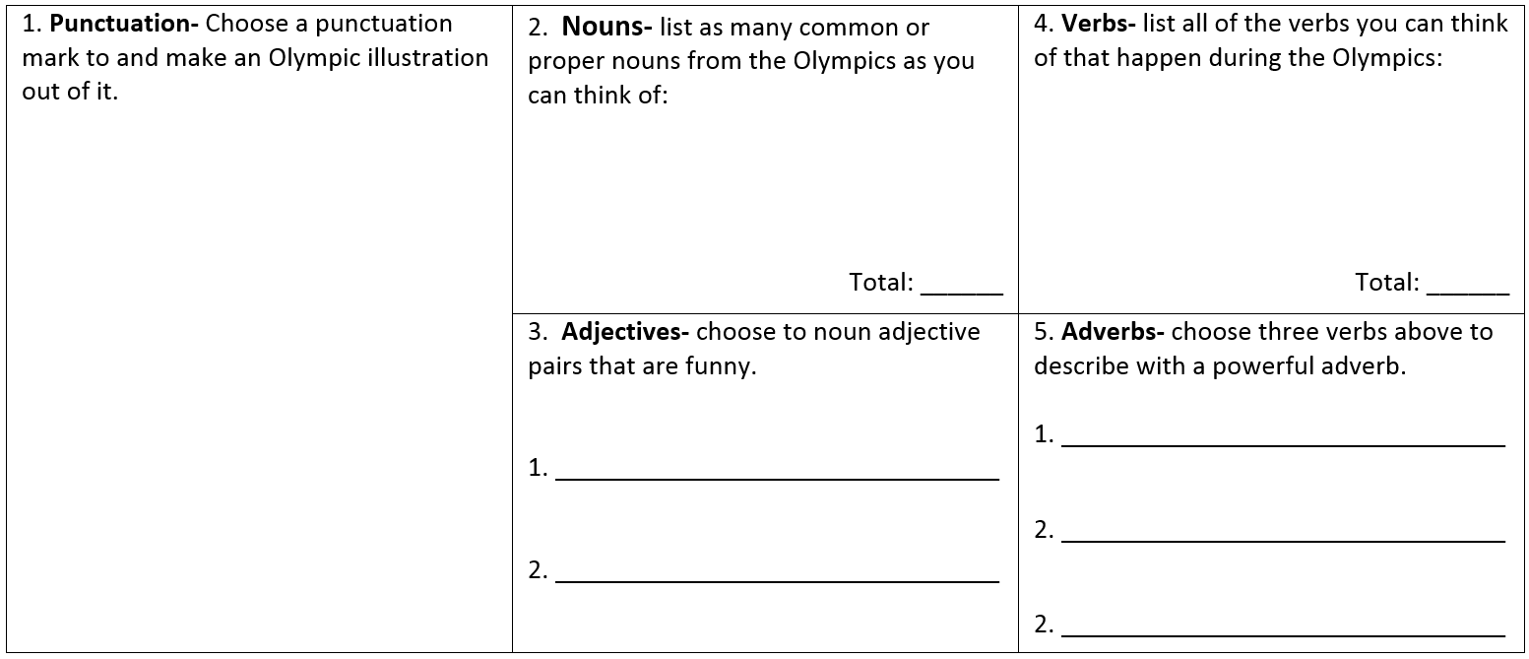
Directions: Answer the questions below. Be prepared to share your answers with the class.

