/ Name:

Period:
Citing Evidence & Commenting on It

Directions: Find, cite (use a title, author, or speaker tag) and write inferences for evidence that supports this argument.
Claim: Utah lawmakers should update our drone laws.
Reasons: 1) Many residents will be getting them for Christmas 2) Owners need to know the laws. 3) Drones are potentially dangerous and need regulations.

Reason #1: Many residents will be getting them for Christmas
Evidence #1: Tag type:
Inference:
Evidence #2: Tag type:
Inference:
Reason #2: Owners need to know the laws.
Evidence #1: Tag type:
Inference:
Evidence #2: Tag type:
Inference:

Reason #3: Drones are potentially dangerous and need regulations.
Evidence #1: Tag type:
Inference:
Evidence #2: Tag type:
Inference:
Directions: Consider what people who disagree might say. Come up with a counterclaim along with the evidence and inference to prove it wrong.

Counterclaim:
Rebuttal #1: Tag type:
Inference:
REFLECTION: Explain why tags and inferences are necessary in argument writing. Then, offer tips for other students to help them remember how to use them.

Drones are fun, drones are popular, but drones can also be dangerous
By The Record, adapted by Newsela staff
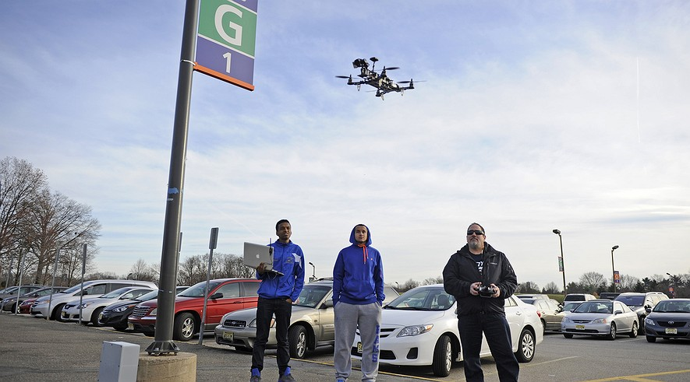
Bergen Community College STEM students (from left) Abreham Mindaye, 19, and Jose Tejada, 19, work with Steve Cohen, who teaches about unmanned avionics, to map construction on the college's Paramus, New Jersey, campus using a drone. Photo: Amy Newman/The Record/TNS

HACKENSACK, N.J. — The hot Christmas present this year isn’t a doll, a toy or a video game. It’s a small flying aircraft with a camera attached — a drone.
There’s the DJI Phantom 2 Vision, a drone which has four propellers and a high-definition camera. USA Today recently called this drone, which sells for $1,200, a top holiday gift for 2014. There’s also the Parrot AR 2.0, selling for $395 on Amazon.

Want to entertain the family for less than a hundred dollars? No problem. Radio Shack is selling the Surveyor Drone. It’s red, it shoots video, and it’s cheap — just $60 this holiday season.

Getting Better All The Time

Rob Powley of Mahwah, New Jersey, has so many drones that he forgets the exact number. He bought some preassembled and built others himself.

“I bought them because they’re cool,” Powley said. “It’s amazing what you can do with a drone. And they’re getting better all the time.”

For years, drones were mostly used by the military for top-secret missions and then for bombing and surveillance in Iraq and Afghanistan.

Now, drones are available to the average consumer, offering low-cost, fun, and easy-to-use cameras. But more drones in the skies are also bringing problems for pilots, tourists in national parks and even pedestrians.

Drones are increasingly bringing up concerns over safety and privacy. There are calls for more regulation of drones by state governments and at the federal level. The fun gift you get under the tree this year may face many tight new regulations in the future.

Laws Are Confusing

The laws covering drones vary by state, city and town, said Wells C. Bennett, who studies national security law at the Brookings Institution. Bennett said. “A lot of the laws will change over the next couple of years.”

Only five years ago, drones available to consumers simply didn’t exist, said Mike Blades, an aerospace-industry analyst for market-research firm Frost & Sullivan.

Since then, sales of drones have exploded. Blades estimates consumers will spend $720 million on drones this year. Next year, that will double, which amounts to about 200,000 drones sold every month, he believes.
Drones are easier to fly than traditional radio-controlled planes and helicopters because they often have four rotors and advanced microchips to help stabilize flight. Drones also move differently — replacing an airplane's smooth dips and arcs with the sharp turns of a robot.
Drones take off vertically, shooting straight up into the sky.

With old-fashioned radio-controlled planes, you need a lot of space, Powley said. But a small quadcopter drone can be flown inside a house. In fact, Powley does fly his drones around his house and office.

Look Out Below!

Many military drones were designed for stealth, made to be as quiet as possible. There’s nothing sneaky about most drones for consumers, though.

Drones’ propellers hum at different pitches, creating a racket like a hive of angry bees. If a drone runs out of batteries, it’s likely to fall out of the sky like a stone. Cheaper drones may fly for just a minute or two, while more expensive models may fly for around 12 minutes, drone users said.

The biggest difference between radio-controlled planes and drones is cameras. Today, small, light cameras such as GoPros can fly on drones and transmit photos and video instantly back to smartphones, tablets and computers.

New technologies like LIDAR cameras use lasers to operate like radar and can make intricate 3-D models of land and territory from the sky. They can even spot people through trees, making them useful for military and police.

Close Call With A Jet

As these technologies get lighter and cheaper, “they will be affordable for anyone to buy in the next 10 years,” Blades said.

Lighter equipment and better batteries also mean that drones in the near future will fly higher, farther and faster than anything available for sale today. Concerns about privacy and the safety of consumer drones are growing, too.

The National Park Service temporarily banned drones on all the land it manages after receiving complaints about drones at Mount Rushmore, the Grand Canyon and Yosemite.

Since July, the Federal Aviation Administration (FAA), which controls airports and aircraft in the U.S., has been receiving 30 complaints a month from pilots who have had close calls with drones or seen them flying in restricted airspace near airports.

On Sept. 8, for example, the pilots of three different passenger jets reported “a very close call” with a drone at about 1,900 feet as they flew their final approaches into LaGuardia Airport in New York City.
Even a small drone could bring down a jet.

Shooting A Neighbor's Drone

Others worry that drones could be used to invade people’s privacy.

In September, Russell Percenti of Lower Township, New Jersey, became so angry at his neighbor for flying a drone over his house that he shot the drone down with a shotgun. Percenti was arrested and charged with unlawful possession of a weapon and criminal mischief.

“With small hobbyist drones with high-definition cameras, it’ll be easy enough to peek into your neighbors’ backyard anytime you want to, even if they have a very high fence,” said Jeramie Scott of the Electronic Privacy Information Center.

Drone supporters say privacy concerns are exaggerated. A good pair of binoculars is a better spying tool than a drone, which can only fly for a few minutes at a time and makes a loud buzzing noise, said Michael Drobac, of a business trade group that represents drone makers.

