Name: _______________________
Computer #: ______
Personal Narrative: LAB INSTRUCTIONS
- Log in to the computer with your student #.
- Open Google Chrome.
- Go to gmail.com and log in to your student email account.
  - your email is your last name, the first 2 initials of your first name @wsdstudent.net
  - your password is your student #
- Once you’re in your email, read the email and open the two documents I shared with you.
- To make a copy of the Template document:
  - Click File then Make a Copy.
  - Name your document Personal Narrative_(your initials)
  - Click Share, and then type my email address (jenorr@wsdstudent.net) in the box. See pictures below.
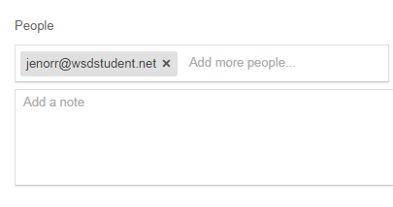
  - Double check that the name of your document has changed to have your initials and that you have shared it with me before you move on.
- Using your peer reviewed draft, storyboard, and brainstorming type your story.
- Replace all of the example text with your own.
- Spell Check your article by clicking on Tools and then on Spelling.
- Carefully read article aloud to yourself.
- Do not print today.
Name: _______________________
Computer #: ______
Personal Narrative: LAB INSTRUCTIONS
- Log in to the computer with your student #.
- Open Google Chrome.
- Go to gmail.com and log in to your student email account.
  - your email is your last name, the first 2 initials of your first name @wsdstudent.net
  - your password is your student #
- Once you’re in your email, read the email and open the two documents I shared with you.
- To make a copy of the Template document:
  - Click File then Make a Copy.
  - Name your document Personal Narrative_(your initials)
  - Click Share, and then type my email address (jenorr@wsdstudent.net) in the box. See pictures below.
  - Double check that the name of your document has changed to have your initials and that you have shared it with me before you move on.
- Using your peer reviewed draft, storyboard, and brainstorming type your story.
- Replace all of the example text with your own.
- Spell Check your article by clicking on Tools and then on Spelling.
- Carefully read article aloud to yourself.
- Do not print today.

