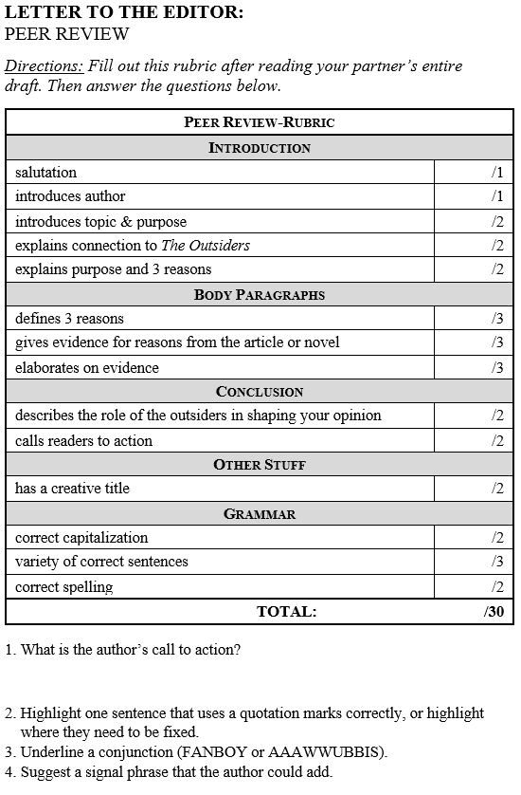
LETTER TO THE EDITOR:
PEER REVIEW

Directions: Fill out this rubric after reading your partner’s entire
draft. Then answer the questions below.
Peer Review-Rubric
Introduction
salutation | /1
introduces author | /1
introduces topic & purpose | /2
explains connection to The Outsiders | /2
explains purpose and 3 reasons | /2
Body Paragraphs
defines 3 reasons | /3
gives evidence for reasons from the article or novel | /3
elaborates on evidence | /3
Conclusion
describes the role of the outsiders in shaping your opinion | /2
calls readers to action | /2
Other Stuff
has a creative title | /2
Grammar
correct capitalization | /2
variety of correct sentences | /3
correct spelling | /2
TOTAL: /30

1. What is the author’s call to action?

2. Highlight one sentence that uses a quotation marks correctly, or highlight
where they need to be fixed.
3. Underline a conjunction (FANBOY or AAAWWUBBIS).
4. Suggest a signal phrase that the author could add.

