Name: _______________________
Computer #: ______
Poetry Portfolio: LAB INSTRUCTIONS
- Log in to the computer with your student #.
- Open Google Chrome.
- Go to gmail.com and log in to your student email account.
  - your email is your last name, the first 2 initials of your first name @wsdstudent.net
  - your password is your student #
- Once you’re in your email, read the email and open the document I shared with you.
- Make a copy of the Template document:
  - Click File then Make a Copy.
  - Rename your document Poetry Portfolio_(your initials)
  - Click Share, and then type my email address (jenorr@wsdstudent.net) in the box. See pictures below.
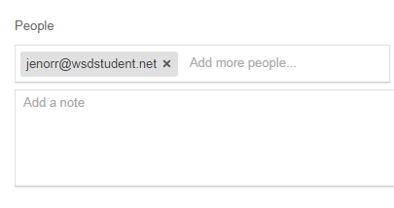
  - Double check that the name of your document has changed to have your initials and that you have shared it with me before you move on.
- Using your revised poems, type each poem in the appropriate spot in your document.
- Annotate the poems by highlighting the part the line or words, then clicking on the comment button in the top right corner.
- Spell Check your article by clicking on Tools and then on Spelling.
Name: _______________________
Computer #: ______
Poetry Portfolio: LAB INSTRUCTIONS
- Log in to the computer with your student #.
- Open Google Chrome.
- Go to gmail.com and log in to your student email account.
  - your email is your last name, the first 2 initials of your first name @wsdstudent.net
  - your password is your student #
- Once you’re in your email, read the email and open the document I shared with you.
- Make a copy of the Template document:
  - Click File then Make a Copy.
  - Rename your document Poetry Portfolio_(your initials)
  - Click Share, and then type my email address (jenorr@wsdstudent.net) in the box. See pictures below.
  - Double check that the name of your document has changed to have your initials and that you have shared it with me before you move on.
- Using your revised poems, type each poem in the appropriate spot in your document.
- Annotate the poems by highlighting the part the line or words, then clicking on the comment button in the top right corner.
- Spell Check your article by clicking on Tools and then on Spelling.

