Poetry & Figurative Language Self-Evaluation
Reading Literature | When I am asked to . . .
 | set a purpose before reading.
 | make inferences as I read.
 | summarize the theme of a text.
 | identify where I get confused as I read.
 | determine most important details as I read.
 | recognize organizational pattern of a text.
 | identify literary devices such as: rhyme, repetition, alliteration and onomatopoeia.
 | interpret figurative language such as: simile, metaphor, hyperbole, allusion, pun, personification
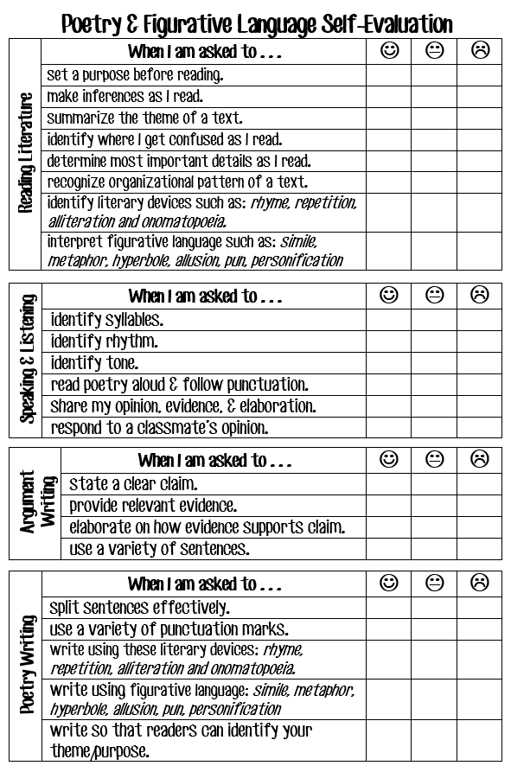

Speaking & Listening | When I am asked to . . .
 | identify syllables.
 | identify rhythm.
 | identify tone.
 | read poetry aloud & follow punctuation.
 | share my opinion, evidence, & elaboration.
 | respond to a classmate’s opinion.
Argument Writing  Argument Writing | When I am asked to . . .
 | state a clear claim.
 | provide relevant evidence.
 | elaborate on how evidence supports claim.
 | use a variety of sentences.
Poetry Writing | When I am asked to . . .
 | split sentences effectively.
 | use a variety of punctuation marks.
 | write using these literary devices: rhyme, repetition, alliteration and onomatopoeia.
 | write using figurative language: simile, metaphor, hyperbole, allusion, pun, personification
 | write so that readers can identify your theme/purpose.

